Reflection Paper

**Van Lang University**

**Capstone Project**

**K14T**

**1/12/2012**

Team 05

This document specify some difficulties, solutions, and lesson learn from facing against them in each phase while developing Personal Information Management module from Human Resource Management for Capstone Project in 2011 – 2012.

# Revision History

|  |  |  |  |
| --- | --- | --- | --- |
| Name | Date | Reason for changes | Version |
| Nguyen Dinh | 01/12/2012 | initial version, add reflection for architect and project management phase | 1.0 |
| Nguyen Dinh | 04/22/2012 | Update Project Management reflection | 1.0.1 |
| Nguyen Dinh | 04/25/2012 | Update requirement reflection | 1.0.2 |
|  |  |  |  |
|  |  |  |  |
|  |  |  |  |
|  |  |  |  |
|  |  |  |  |
|  |  |  |  |
|  |  |  |  |
|  |  |  |  |

1. Introduction

# Product Overview

Personal Information Management (PIM) is a module within Human Resource Management system for Van Lang University. It helps Human Resource Planning and Managing Department easy to manage staffs’ information.

# Document Overview

This is a “live” document, which is developed and updated throughout project developing duration. Although there are many processes that we used in our project, we will only choose the main processes to write reflection for simplifying this document. In reflection section, there are five small chapters represent for each phase of developing PIM. They are:

* Project Management,
* Requirement,
* Architecture and Design,
* Implementation,
* And Testing.

1. Reflection

# Project Management

## Methodology

## Agile and Traditional Methodology

HRM Project team analyzes five attributes: Size, Culture, Dynamism, Personnel, and Criticality.

* **Criticality**: Traditional methods require all/ most requirements defined up front so that we can easily plan and create budget. In addition, we only have twenty-two weeks for requirement phase and after that is signed contract between the HRM team and customers. Therefore, the score is close to traditional.
* **Size**: HRM team realized that the size of Human Resource Management project is relatively big and it will take thirty-seven weeks for development. Therefore, traditional methodology is suitable with HRM project.
* **People:** not all members in HRM team are equally good at software development and the imbalances stresses in design and coding. Therefore, one member cannot assume the roles at the same time. Besides, the skill in programming of team member is not good and no one readies for new technology. Therefore, choosing agile methodology is not a wise decision.
* **Dynamism**: In HRM project, the requirement will be base lined after twenty-two weeks. Therefore, customers cannot change major requirements anymore.
* **Culture:** Up to now, all members in team had always done project using traditional methodology. It means that everything must follow by the policy and procedures.

## The V Model

Therefore, based on five attributes to choose a methodology, HRM team decided to choose traditional method for development, and typically, V-Model. The V-Model represents a software development process, which may be considered an extension of the waterfall model. Instead of moving down in a linear way, the process steps are bent upwards after the coding phase, to form a typical V shape. The V-Model demonstrates the relationships between each phase of the development life cycle and its associated phase of testing. In addition, if there are defects in architect phase, it will be return in requirement phase for updating the requirements.

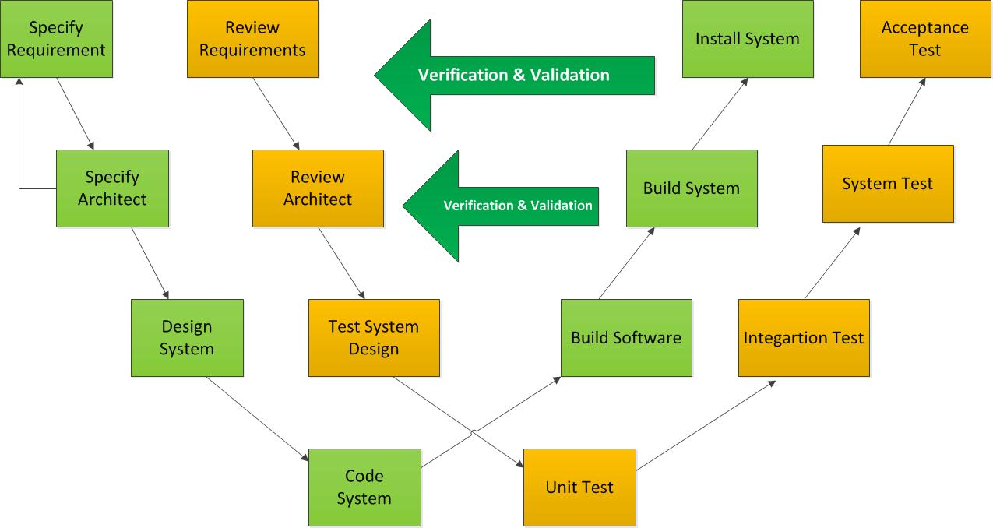

In Human Resource Management project (HRM), after many meetings between the members in team, everyone united to choose V-model for HRM project. There are some reasons for this decision:

1. The V-model helps to minimize the project risks by specifying standardized approaches and describing the corresponding results and responsible roles. It permits an early recognition of planning deviations and risks and improves process management, thus reducing the project risk.
2. Improvement and Guarantee of Quality: the V-model ensures that the result to be provided is complete and has the desired quality.
3. Reduction of total cost: The V-model can help you to calculate the effort of development, production, operation and maintenance of a system.
4. Improvement of Communication between all stakeholders: each step in V-Model (requirement, design, code, test …) must be verified and validated among stakeholders and it can help to improve the communication between the stakeholders.

However, the V-Model has also some disadvantages that need improving:

1. Just only in one way and we cannot return in the previous steps to fix the defects. For example, if we are in design phase, we cannot return in the requirement phase to change the requirement.
2. Time consuming for verifying and validating the same thing repeatedly
3. High complexity, it requires the measurements and we need to control the process closely.

## Changes in methodology

There are five reasons for choosing this model.

1. It is a linear model, which is very simple to implement
2. Easy to manage due to the rigidity of the model, each phase has its specific deliverables.
3. The amount of resource to implement this model are minimal
4. Works well for smaller projects and completed once at a time.
5. Documentation is produced at every stage of software’s development. It makes us simpler to understand the product designing procedure

We integrate it with Incremental-model for detail design, programming, testing because of easily, quickly and early to generate working software during the software life cycle:

1. Less cost to change detailed design, implementation since team members are not good at detail design and programming
2. Easy to test and debug during a smaller iteration
3. Easy to manage because of smaller iteration

The Architecture Centric Design Method (ACDM) address these issues and provide a more comprehensive design process that can easily be meshed with existing process frameworks. We use ACDM for Requirement phase and Architecture phase because:

1. It provides techniques and a structure for designing architecture and then using it to guide the programmatic aspects of a project
2. It guides project planning, tracking, and construction



## Lesson Learnt

This is the most important phase for developing PIM. It is started from the very beginning of the project and closed after the product is delivered. In this phase, we must define the fittest schedule and a perfect plan for capstone project.

We decided to add five people in charge for this phase, they are one leader who is the ultimate one, and four leader of each developing phase. However, we still face some challenges, which are shown in the following table. Upon these difficulties, we did learn much useful knowledge.

|  |  |  |  |
| --- | --- | --- | --- |
| No. | Difficulties | Solution | Lesson Learnt |
| 1 | Members don’t care about Risks in project and don’t update Risk Category | Follow risk plan, plan about integration for risk | Knowing more about manage risk better |
| 2 | Too much and more difficult to measurement | Research about measurement, implement Goal-Question-Metric | Knowing more definite about metrics and how to get it |
| 3 | Project difficult to control and monitoring | Plan for detail plan, WBS, implement tracking and monitoring through measurement about schedule deviation metric |  |
| 4 | 360 review is not good conduct | Require team member write reflection base on 360 review | Knowing about management and communicate between team member |
| 5 | Team member is not complete work on time | Re-estimate, and evaluate effort of team member | Conduct measurement about productivity |

# Requirement

## 2.1 Requirement process

Using V-model, we created a requirement process that can help us improve communication among team and customers in addition to checking and ensuring the output quality.



## 2.2 Changes

Although the previous process is great for eliciting and analyzing requirement, it takes so much time to proceed. However, we do not consider ACDM clearly when apply it to our project. Therefore, this process is only great on theory; when using it, we face some problems

* ACDM has its own requirement process, applying ACDM to our system means we have to use both ACDM requirement process and out process
* In V-model, after finishing requirement phase, we can move to design phase. However, we cannot apply to our project because we have to finish requirement documents together with architecture design and detailed design, which means they must go parallel.
* Moreover, what we have done is not even close to our plan.

To overcome these problems, we have to update our plan and we have decided to cut the previous process and use stage one and two of ACDM as our main requirement process.

## 2.3 Lesson learnt

|  |  |  |  |
| --- | --- | --- | --- |
| No. | Difficulties | Solution | Lesson Learnt |
| 1 | Customers do not exactly know what they want | We consult them of what a general human resource may look like and encourage them to speak what they need | Carefully research about what are they doing before getting requirements because customers can constantly do their jobs without knowing the essence of them. |
| 2 | Customers want many things but they do not care about consequences | Try to cut their flows and lead them to main functions, some extra requirements will be collected but considered to be developed in this version | Try to negotiate with customers using time, quality constrains. |
| 3 | Customers hesitate to sign requirement contract because they want to change more | Although they do not want to sign contract, we focus on some main documents, which mostly affect other phases’ works, so that they can change what they want and sign them quickly | Instead of signing all documents at one time, we can negotiate with our customers to sign them individually so that they will be willing to do so. |

# Architect and Design

In this phase, we will develop a design that can be easily implemented later. Therefore, we must choose the best architect for HRM in general, and PIM in specific.

To make the product more useful and friendly, we have to choose Silverlight, which is quite difficult for us. In addition to this difficulty, all challenges are described in the following table

|  |  |  |  |
| --- | --- | --- | --- |
| No. | Difficulties | Solution | Lesson Learnt |
| 1 | There are a lot of technologies that need to be researched | Spending more effort for researching about new technologies, e.g. WCF, MVVM,Telerik… | Knowing more about how using the WCF,MVVM, Telerik in architect. |
| 2 | The important requirements changes so much | Dealing with the customer to give the specific baseline. | Everything we do need to be baselined to make sure that the customer will not change the requirement |
| 3 | Being lack of the experiences in architect, so it is difficult to get the consensus between the architect and detail design | Asking the mentor and the internet for the solution in architect to give the good architect. Besides, explaining about the architect and dealing with design team are necessary | Researching more about the new technologies that are used in architect to give the accuracy architect |
| 4 | Being lack of the resource for architect phase, so that it makes the schedule is always behind | "Recruiting" more resource for architect phase | Apportioning the resource in each phase appropriately. Avoiding being lack of resource |
| 5 | Requirement phase is always behind the schedule | Dealing with the Requirement team to give the consensus about the key requirement for architect | Communicating with Requirement team to get the key requirements. Avoiding waiting the requirement phase has done and then start the architect phase |

# Implementation

|  |  |  |  |
| --- | --- | --- | --- |
| No. | Difficulties | Solution | Lesson Learnt |
| 1 |  |  |  |
| 2 |  |  |  |
| 3 |  |  |  |
| 4 |  |  |  |
| 5 |  |  |  |

# Testing

|  |  |  |  |
| --- | --- | --- | --- |
| No. | Difficulties | Solution | Lesson Learnt |
| 1 |  |  |  |
| 2 |  |  |  |
| 3 |  |  |  |
| 4 |  |  |  |
| 5 |  |  |  |